# Microbit projects: A legged robot

## The aim

We’re going to build a legged robot. Our final robot will have 6 legs, much like a crawling insect. But it’s a bit hard to do this all in one go, so we’ll work towards it in stages.

1. Build a 4-wheeled robot, and control it remotely. Two of the wheels will be powered and two will be free running.
   * Aim: learn about continuous rotation servos and radio control.
2. Build a robot with 4 free running wheels at the corners and 2 powered legs in the middle.
   * Aim: learn about platform dynamics with legs without having to worry about keeping the robot supported.
3. Build a robot with 2 free running and 2 powered legs at the corners - each leg now has to step separately or the robot will fall down.
   * Aim: learn about stepping. You will need another sensor here to know when the leg is on the ground
4. Build a robot with 6 powered legs.
   * This is our ultimate goal, bringing it all together. This robot still relies on stepping, but gaits, speeds, etc. now become interesting problems.

Obviously insects have brains and sensors that range from eyes to very sensitive hairs, so they can control how they move (and why they move) by themselves – they are autonomous. Even though insects are simple, this is a hard thing to do, so we’ll make remote controlled robots for now.

## A sketch

# Skills needed

* Radio control
* Controlling continuous rotation servos
* Hall effect sensors

## Let’s begin: Radio control

First up, then, is making two MicroBits talk to one another. By itself, this isn’t all that hard, but it gets a bit more complicated in a room full of MicroBits all trying to talk to a partner.

Each MicroBit can both send and receive messages (which we call datagrams). Let’s build two programs – one for a sender, and one for a receiver. We’ll put them on different MicroBits and see if the sender can send something useful to the receiver.

### The sender

The general idea is to wait for a button to be pressed and then to send a datagram containing information about which button it was. But, to stop every sender talking to every receiver in the class, we need to set something special about each pair. In MicroBit-speak this means setting a unique ‘group’ number.

Set the group to be your group

Switch on the radio

onButton is called if there’s a button event

Listen for any button event – call onButton if there is one

1. **Create a new project for the MicroBit, called ‘sender'**
2. **Type in the following code and save it as sender.cpp in the source directory**
3. **You should replace ‘123’ in the setGroup line with your group number.**

#include "MicroBit.h"

MicroBit uBit;

void onButton(MicroBitEvent e)

{

if (e.source == MICROBIT_ID_BUTTON_A && e.value == MICROBIT_BUTTON_EVT_CLICK)

uBit.radio.datagram.send("1");

if (e.source == MICROBIT_ID_BUTTON_B && e.value == MICROBIT_BUTTON_EVT_CLICK)

uBit.radio.datagram.send("2");

}

int main()

{

uBit.init();

uBit.radio.setGroup(123);

uBit.radio.enable();

uBit.messageBus.listen(MICROBIT_ID_BUTTON_A, MICROBIT_EVT_ANY, onButton);

uBit.messageBus.listen(MICROBIT_ID_BUTTON_B, MICROBIT_EVT_ANY, onButton);

while (1)

uBit.sleep(100);

}

1. **Now compile the code and flash it to a MicroBit**

### The receiver

The receiver is similar - we need to wait for a message to arrive and then do something with it. Much like a button press, we can’t know when that will be, so we listen for an event which is the arrival of the data rather than the press of a button.

Set this to the same group as before

onData is called if some data arrives on the network

Listen for a datagram to arrive – call onData if it does

Switch on the radio

1. **Create a new project for the MicroBit, called ‘receiver'**
2. **Type in the following code and save it as receiver.cpp in the source directory**
3. **You should replace ‘123’ in the setGroup with your group number.**

#include "MicroBit.h"

MicroBit uBit;

void onData(MicroBitEvent)

{

ManagedString s = uBit.radio.datagram.recv();

if (s == "1")

uBit.display.print("A");

if (s == "2")

uBit.display.print("B");

}

int main()

{

uBit.init();

uBit.radio.setGroup(123);

uBit.radio.enable();

uBit.messageBus.listen(MICROBIT_ID_RADIO, MICROBIT_RADIO_EVT_DATAGRAM, onData);

while (1)

uBit.sleep(1000);

}

1. **Now compile the code and flash it to a different MicroBit to your sender**
2. **Plug in battery packs to the sender and receiver and see if you can send messages from one to the other**

This is the basis for the remote control. Press button A and it goes left, button B and it goes right. You could use long presses or presses of both A and B, etc., etc. to change speed, or stop it. But it’s also useful to have data come back from the ‘receiver’ on a robot to the ‘sender’ remote control to help you debug what’s actually happening on the bot. To make this happen, try the following:

1. **Change your receiver code so that it sends the temperature back to the sender when a button is pressed. You will need to convert the temperature value from an integer to a string to do this. Use this line of code to create a string variable** t **containing the temperature:**

ManagedString t(uBit.thermometer.getTemperature());

1. **Display this temperature on the sender.**

### Useful stuff

1. **There are useful things you can do with the buttons to help make a more sophisticated remote control. Two buttons probably isn’t enough.**
2. **At the moment, we have an event generated whenever button A is pressed or button B is pressed, and we command that with the following lines in the main routine:**

uBit.messageBus.listen(MICROBIT_ID_BUTTON_A, MICROBIT_EVT_ANY, onButton);

uBit.messageBus.listen(MICROBIT_ID_BUTTON_B, MICROBIT_EVT_ANY, onButton);

1. **But we actually have other ‘buttons’ we can use. For example,**

uBit.messageBus.listen(MICROBIT_ID_BUTTON_AB, MICROBIT_EVT_ANY, onButton);

**ensures that an event is generated and** onButton **called when BOTH buttons are pressed together. Write some code to make use of this (you will later use this idea to stop the robot).**

But there’s more ☺

1. **Just to make life even more interesting it is possible to change the onButton code to deal with clicks, long presses, double clicks etc. At the moment, our code looks like:**

void onButton(MicroBitEvent e)

{

if (e.source == MICROBIT_ID_BUTTON_A && e.value == MICROBIT_BUTTON_EVT_CLICK)

uBit.radio.datagram.send("1");

if (e.source == MICROBIT_ID_BUTTON_B && e.value == MICROBIT_BUTTON_EVT_CLICK)

uBit.radio.datagram.send("2");

}

1. **The values in the box tell the code tell us to do something when the button is clicked (and only when the button is clicked – try a long press).**
2. **You could replace these values with any of:**

MICROBIT_BUTTON_EVT_DOWN

MICROBIT_BUTTON_EVT_UP

MICROBIT_BUTTON_EVT_CLICK

MICROBIT_BUTTON_EVT_LONG_CLICK

MICROBIT_BUTTON_EVT_HOLD

MICROBIT_BUTTON_EVT_DOUBLE_CLICK

1. **Play with all of this a bit and see what happens – sometimes more than one event is triggered by a button press (but I couldn’t make double click work). Can you make button A do different things depending on whether it is clicked or long clicked?**
2. **What is the maximum range of the radio?**

## The continuous rotation serVo

The continuous rotations servo is, as its name suggests, something that rotates continuously rather than turning through a fixed angle as we had before. If you look back at the angular servo, you’ll find that a 1.5ms PWM pulse turns the servo to 90°. In the case of a continuous rotation servo, different pulse widths make the motor run at different *rates* rather than turn to different *angles*. Actually, for this servo, a 1.5ms pulse should tell the motor to be stationary. Shorter pulses cause it to rotate clockwise – the shorter the pulse the faster the speed. Longer pulses cause it to rotate anticlockwise – the longer the pulse the faster the rotation.

### Calibrating the servo

We need to make sure that the motor doesn’t move when we send it a 1.5ms pulse. So, let’s write some code to hold the servo still. Again, rather than send pulses directly, we have written some code to make it easy for you to set speeds.

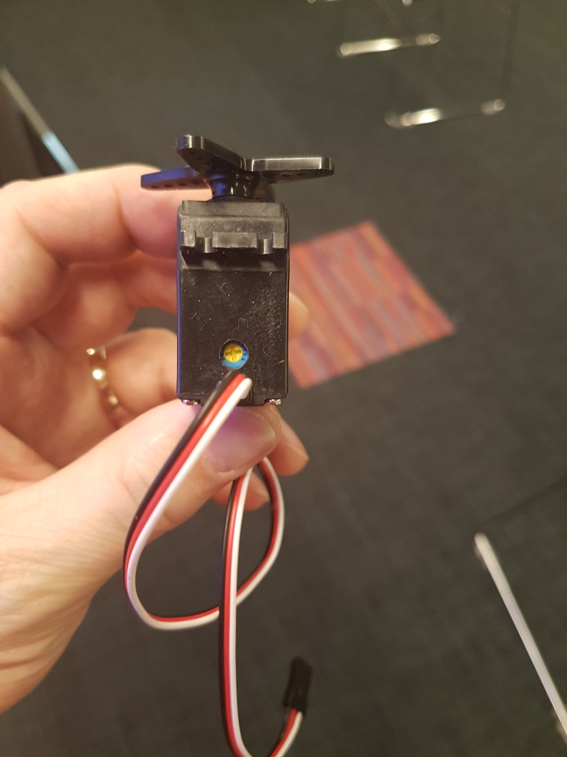

1. **Wire up the servo, PWM board and MicroBit *exactly as for the angle servo*. Look back at the previous project and get your wiring checked before plugging in batteries.**
2. **Create a new project for the MicroBit, called ‘continuous-servo'**
3. **Type in the following code and save it as c-servo.cpp in the source directory**

#include "MicroBit.h"

#include "PCA9685.h"

MicroBit uBit;

PCA9685 pwm(&uBit, speedServo);

int main()

{

uBit.init();

// Set servo 0 to have speed 0

int servo = 0;

int speed = 0;

pwm.setSpeed(servo, speed);

pwm.start();

while (1)

uBit.sleep(10);

}

1. **Now compile the code and flash it to a MicroBit.**
2. **Plug in the battery pack.**
3. **Does the servo rotate? It might not, but it probably will.**
4. **If it does, you need to locate the small screw on the end near the wires:**
5. **Turn this slowly until you’ve fully stopped the servo motor. You’ve now calibrated it.**
6. **Calibrate a second servo by plugging it into output 1 on the PWM board and adapting your code so both servos are going at speed 0.**
7. **Change the above program so that the speed increases (gets more positive) on both servos when you push button A and decreases (might become negative) when you press button B. It should stop if you press A and B together**
8. **The allowed speed settings go from -32 to 32, with 0 being stop.**

The speed of the motors is set using what is called a pulse width modulation signal (PWM).

**clockwise**

**0.5ms**

**stationary**

**1.5ms**

**anticlockwise**

**2.5ms**

**20ms**

**0ms**

**Time /ms**

## Building a robot – robot 3

The first robot we’re going to make is one with 4 wheels. Two free wheels and two powered wheels. But we want to control the robot, so we need to make and test the remote control first.

### radio control

What we’d like is a radio control that:

1. Makes the robot go left when we press A
2. Makes the robot go right when we press B
3. Stops the robot when we press A+B
4. Speeds the robot up when we long press A
5. Slows the robot down when we long press B

We’re going to build this on the bench first.

1. **Connect the MicroBit, PWM board and two servos (to positions 0 and 1)**
2. **Create a new project for the MicroBit, called ‘robot3_TX'**
3. **And adapt your remote control code to make a transmitter that sends a different number to a receiver for each of the five control cases above.**
4. **Flash this to a MicroBit, then disconnect that from the computer and plug in a battery pack**
5. **Create a new project for the MicroBit, called ‘robot3_TX'**
6. **And mix together your remote control code and your servo code to make something that responds to transmitted datagrams in the right way for the five control cases above.**
7. **Flash this to a different MicroBit and demonstrate your code working**
8. **Show this to a demonstrator**

Let’s be double sure you’ve got this right - think about rotation directions:

Looking from the outside of the wheel, the right hand wheel is rotating clockwise, and the left hand wheel is rotating anticlockwise … **we need to make the motors go in opposite directions, but at the same speed** if we’re going to make it go straight.

There are THREE ways we can cause the robot to turn – speed up the motor on the outside of the curve, slow down the motor on the inside, or both.

*Remember that the motors have a maximum speed so there will come a point where you can’t speed one up further.*

1. **Make sure the rotation directions are correct and show that to a demonstrator if you haven’t already**

### Making

We can now build the robot.

You need to connect two free wheels to the robot plus two motorised wheels. You can decide whether you want front wheel drive or real wheel drive.

1. **Attach two servo brackets to the base**

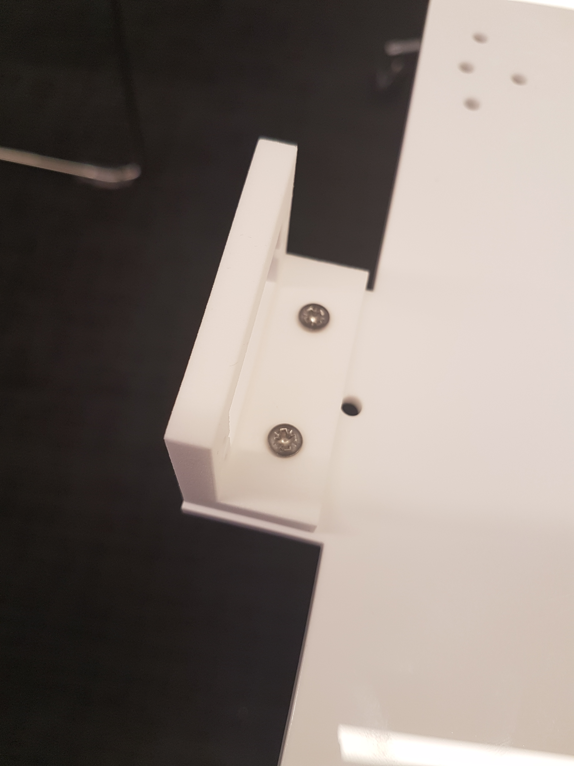

1. **Add the servos to the servo brackets:**

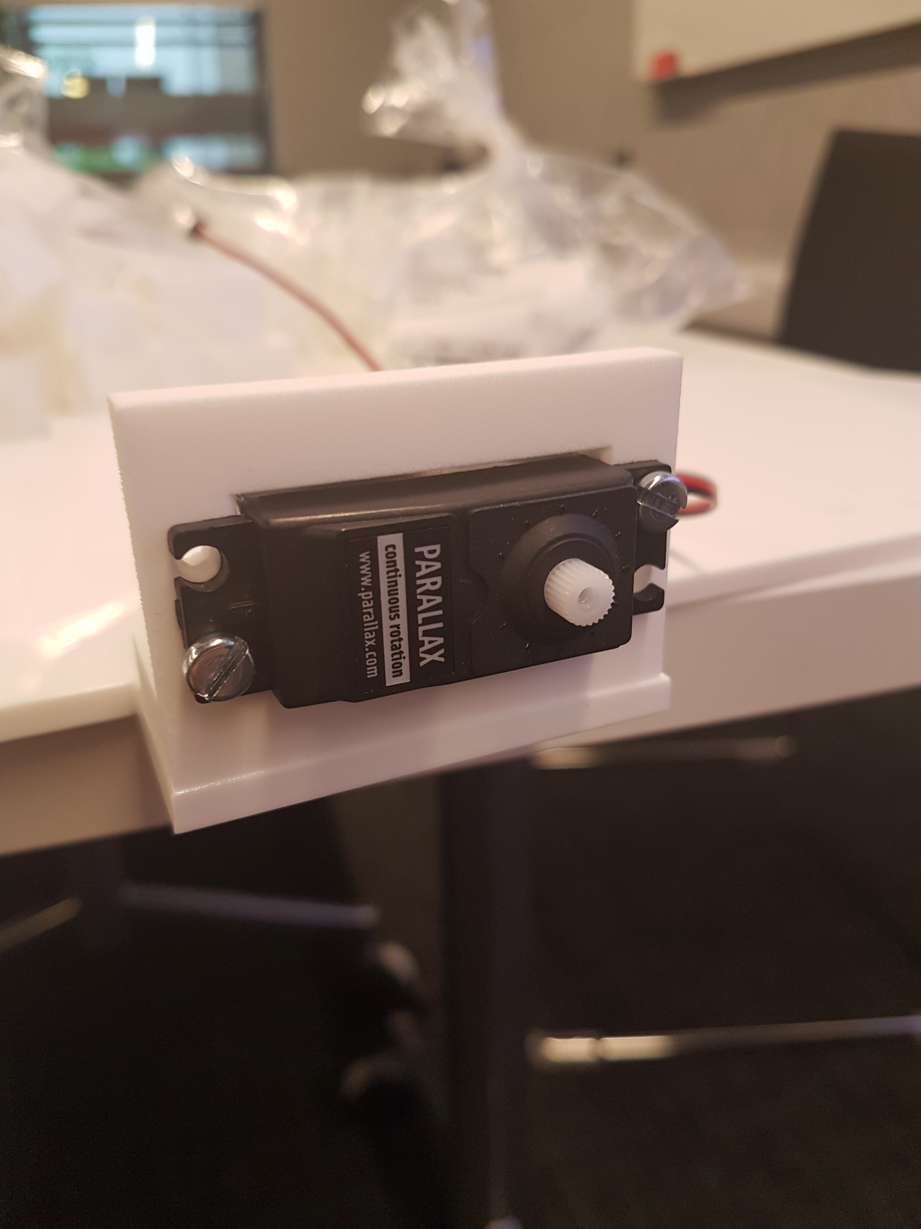

1. **Attach the servo-based wheels to the servos like this:**

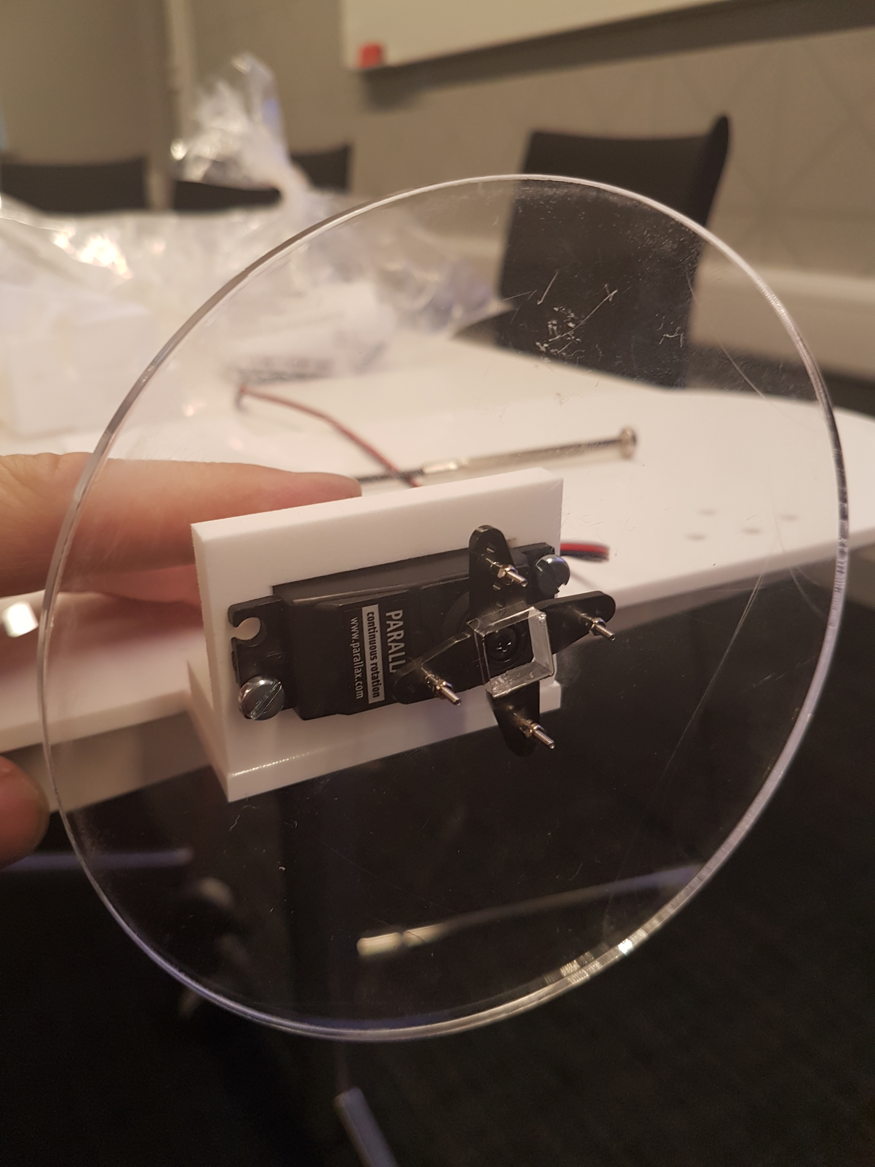

1. **Attach the axle bracket to the base. Thread the axle through the bracket and push a cap on to the other end. Make sure it rotates reasonably freely.**

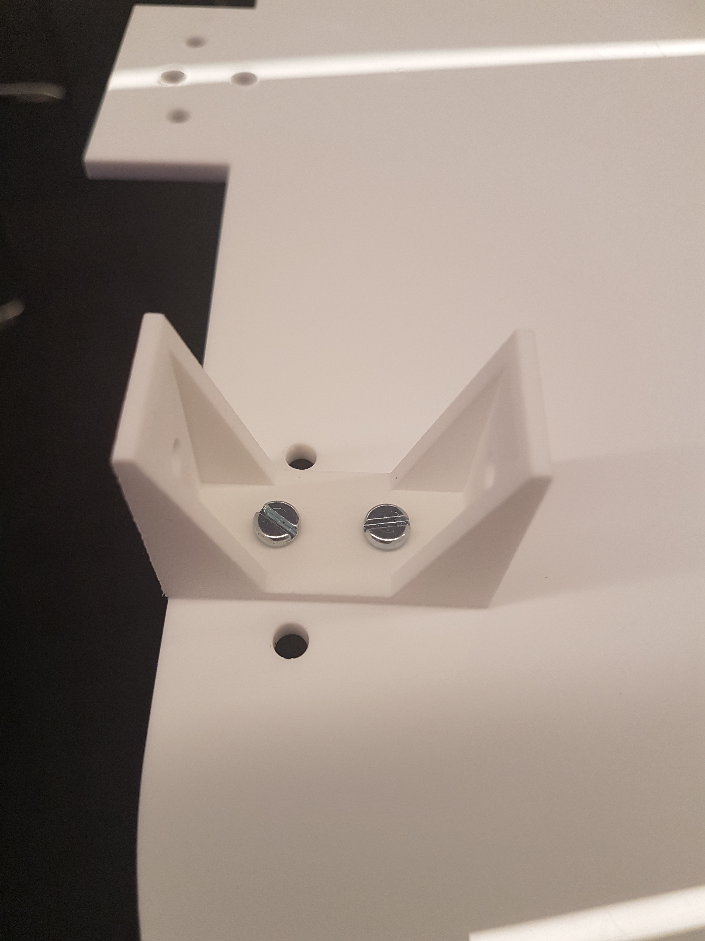 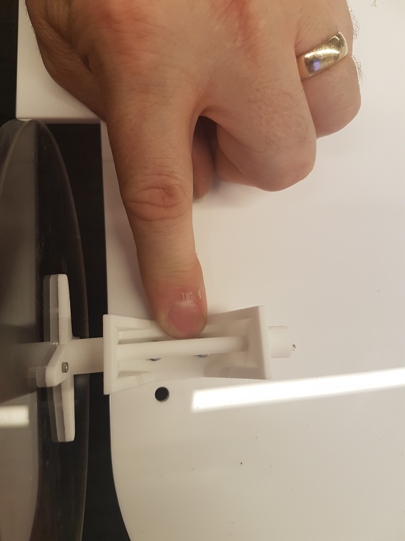

1. **And the free wheels to an axle like this:**

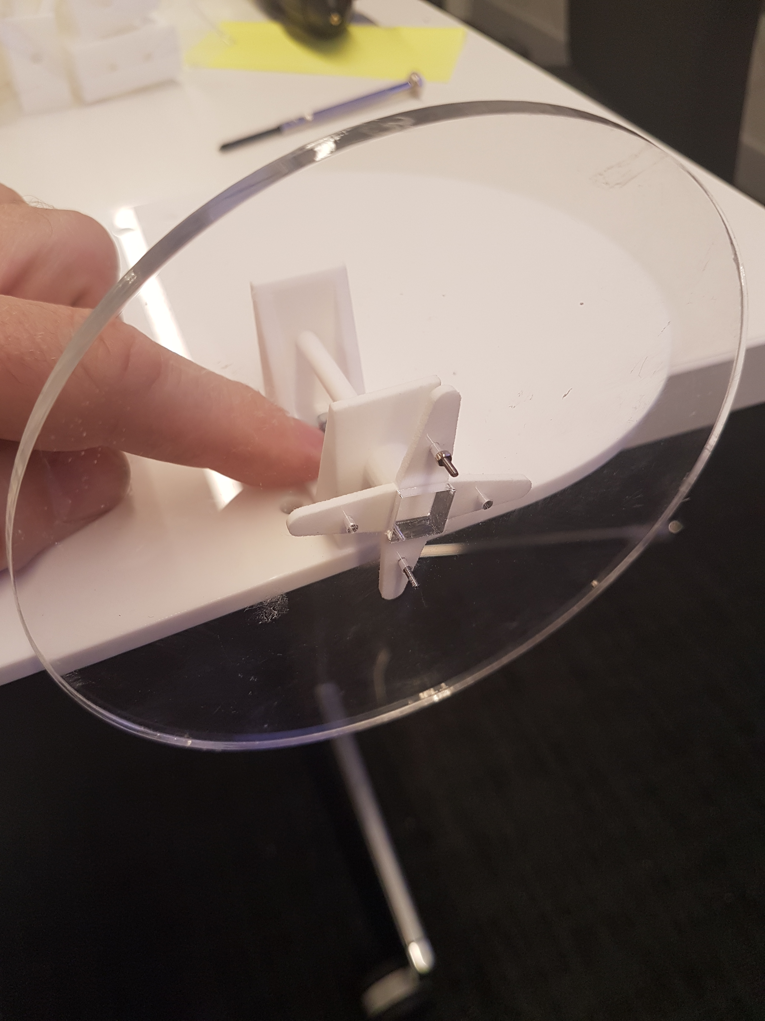

1. **Connect all the electronics and stick it to the top of the base using blu-tack or tape just to stop it all coming loose and getting in the way.**

**PLAY**

## Robot 4

OK, so robot 3 isn’t very bioinspired, so let’s talk about legs. We’re going to go back to robot 3, but have two powered legs at the back instead of wheels.

*THINK ABOUT THIS – WHAT ARE THE PROBLEMS LIKELY TO BE?*

1. **Attach the legs to the servos in the obvious way**
2. **How are you going to phase the legs?**
3. **Now experiment with this – how well does it work? What happens when the leg turns? Does the robot stay level? Can you steer it? If you don’t have enough friction, what can you do about that?**
4. **What might make it work better?**

### Hall effect sensors

So, when we walk, we take distinct steps. One leg at a time. So we need some way to stop the leg rotating when it’s exactly where we want it to be. For that we’re going to use magnets and a Hall effect sensor.

1. **Connect a Hall effect sensor to the MicroBit like this:**
2. **Take the robot off the ground and input the following code**

#include "MicroBit.h"

#include "PCA9685.h"

MicroBit uBit;

PCA9685 pwm(&uBit, speedServo);

int speed = 0; // Initially still

void onEdge(MicroBitEvent e)

{

speed = 0;

}

int main()

{

uBit.init();

// Set a pullup on pin 0.

// And set an event handler for the falling edge

uBit.io.P0.setPull(PullUp);

uBit.io.P0.eventOn(MICROBIT_PIN_EVENT_ON_EDGE);

uBit.messageBus.listen(MICROBIT_ID_IO_P0, MICROBIT_PIN_EVT_FALL, onEdge);

pwm.start();

// Set servo 0 to have speed 10

int servo = 0;

speed = 10;

while(1) {

pwm.setSpeed(servo, speed);

uBit.sleep(50);

}

}

1. **Flash this to the MicroBit.**
2. **Now bring a magnet close to the Hall effect sensor.**
3. **What happens?**
4. **Can you glue a magnet to the leg and place the Hall effect sensor so that it stops the leg when it’s on the ground? Now experiment with this – how well does it work?**
5. **Connect a second Hall effect sensor to pin 1, and adapt the above code so that it works for two legs. Remember: the legs go in opposite directions and only one should be off the floor (taking a step) at a time - you need to switch between the legs.**

## Robot 5

Now do it all for 6 powered legs. Make a plan and discuss it with a demonstrator. You can use pins 0, 1, 2, 8, 14 and 15 for the Hall Effect sensors but you’ll need a bit of breadboard to make all the connections.